**Response, Level F1, Nana Upstairs and Nana Downstairs**

The teacher asked the students to choose a passage from the text that was important to them or had special meaning to the writer. This child chose a double-entry log to respond to Tomie de Paola’s Nana Upstairs and Nana Downstairs. The book’s selected passage is on the left.

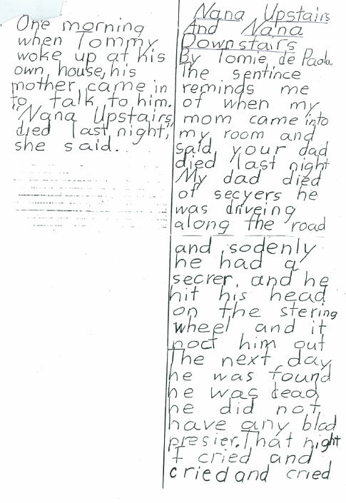

|  |  |
| --- | --- |
| One morning when Tommy woke up at his own house, his mother came in to talk to him. “Nana Upstairs died last night,” she said. | Nana Upstairs and Nana Downstairs by Tomie de Paola  The sentence reminds me of when my mom came into my room and said, “Your dad died last night.”  My dad died of seizures. He was driving along the road, and suddenly he had a seizure. And he hit his head on the steering wheel, and it knocked him out. The next day he was found. He was dead. He didn’t have any blood pressure.  That night, I cried and cried and cried. |

***If you were conferencing with this writer about her very sad story, are there some questions you would like to ask her? Practicing asking each other questions about our writing helps us think about our own writing and how we can add more description for our readers.***